How it’s all organized:
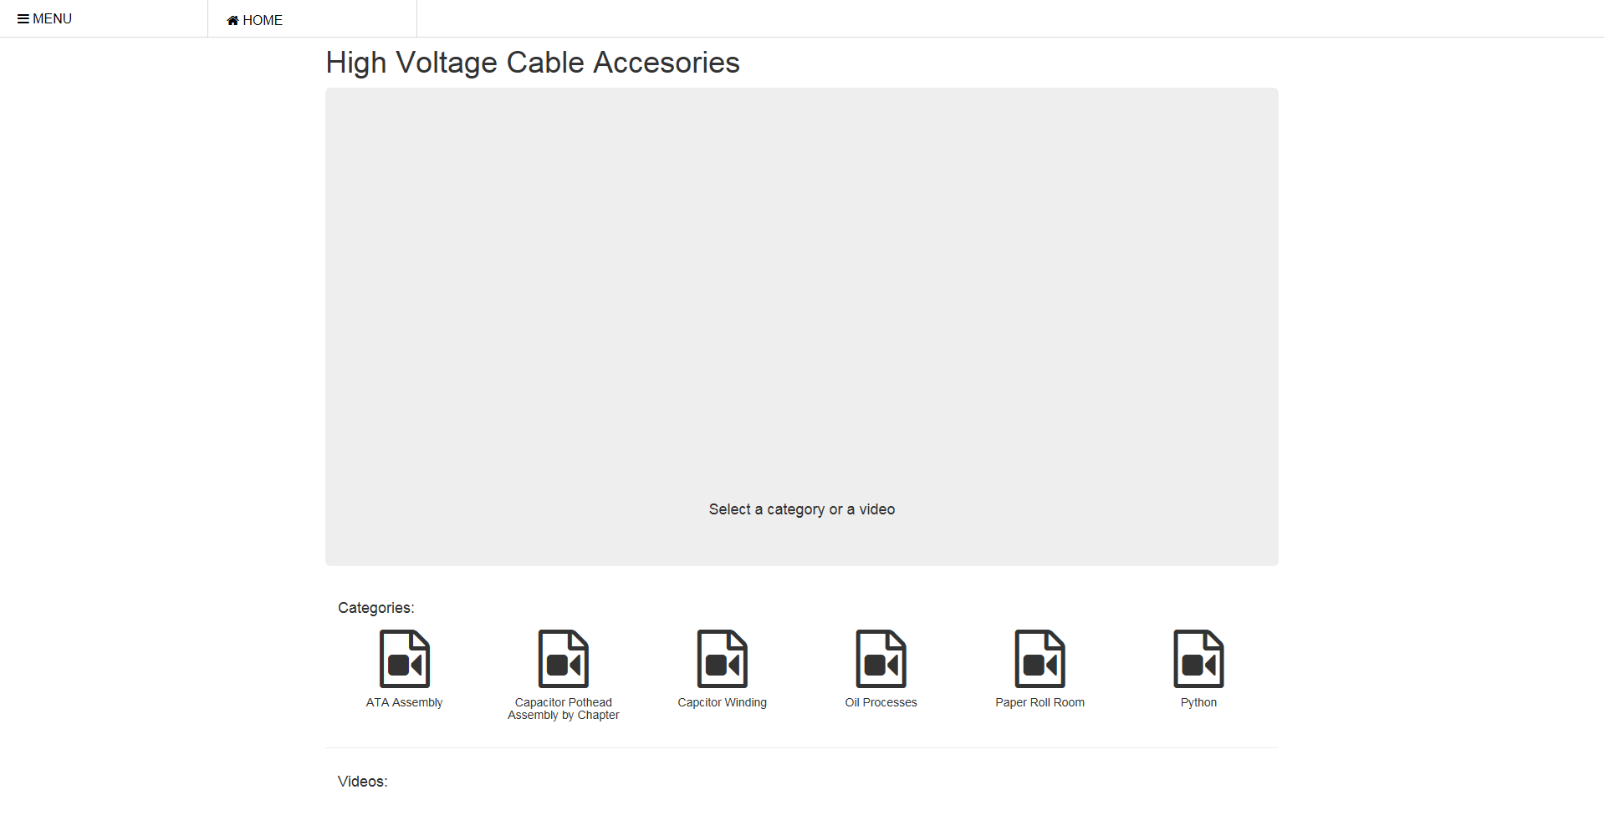
When you open a page it will look like this:
H1 #pageName
This is div.jumbotron. The video player #main_video is inside it.
This is div.top with #icon-menu and #home inside

This is div #categories
This is h4 #vidName
This is a div.playlist

This is div #gallery. Video thumbnails populate in here

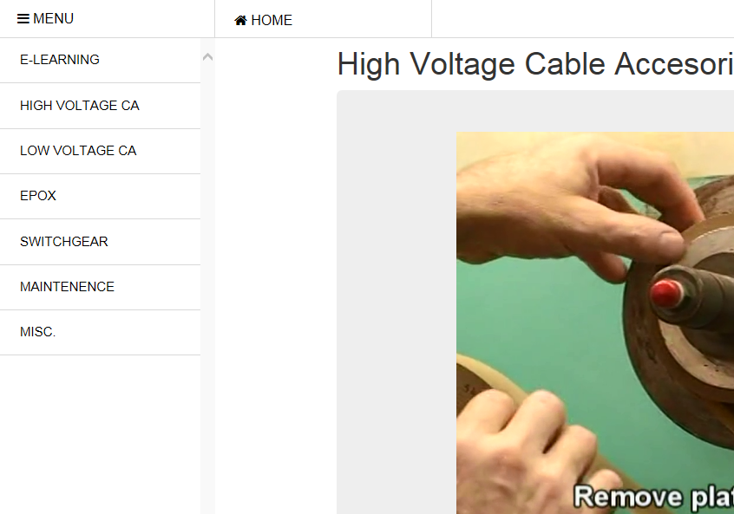
When menu is clicked:
This is div.menu
This is div.menu ul li a

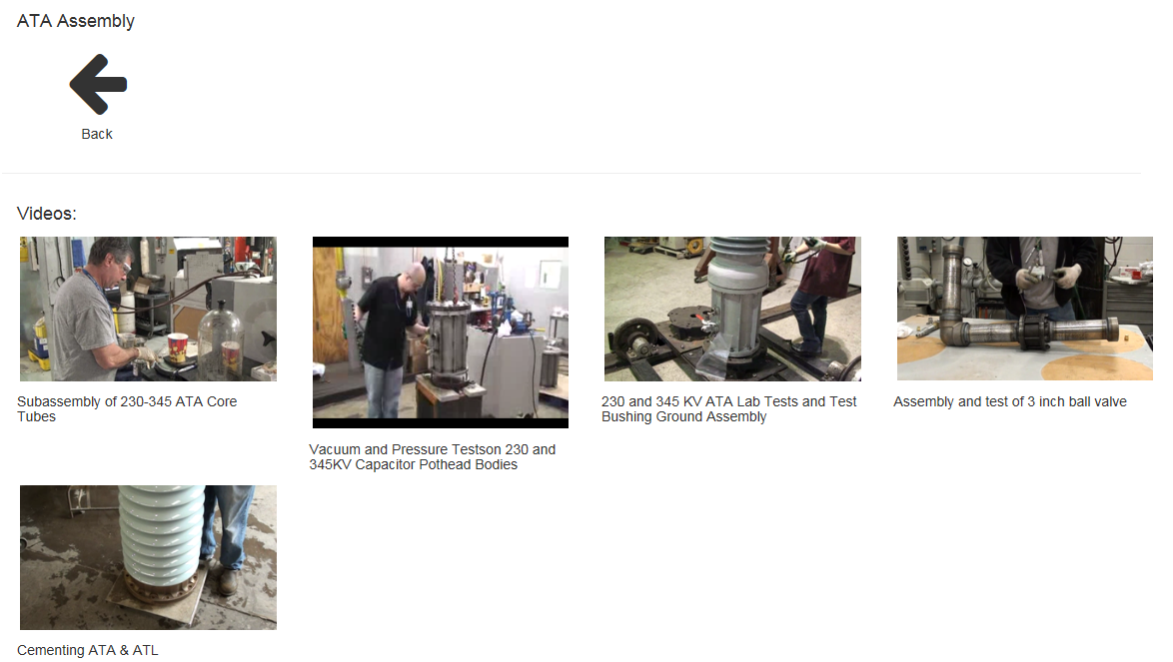
When a category is clicked:
This is div.row visibleRow default extra. It is shown when a category has no subcategories to show. It is hidden by default so instead of visibleRow it has hiddenRow
This is a single img.sml_video. These are in HTML files in the playlist folder
This is div.playlist back

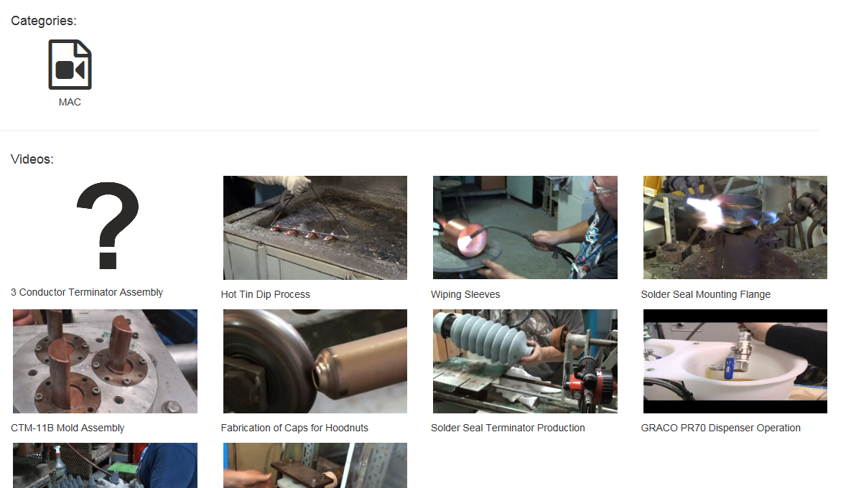
Example of videos on the root:
These are videos not in a subcategory. They are always in a file called rootVideos.html

Bootstrap explained:
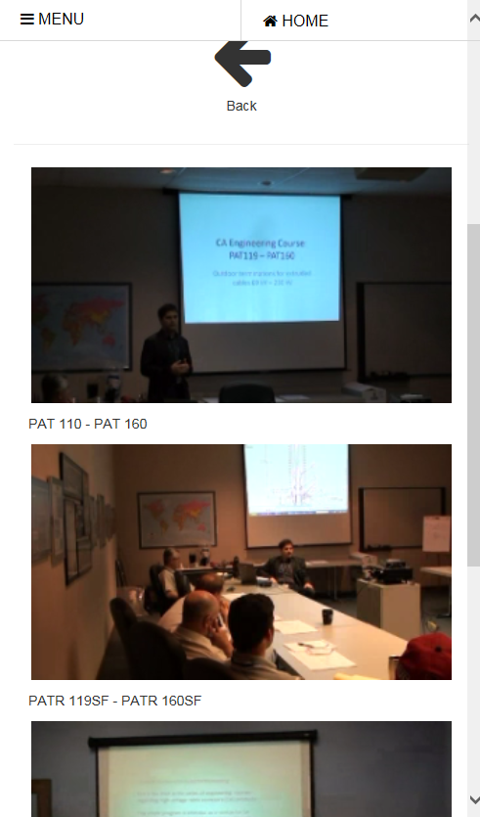
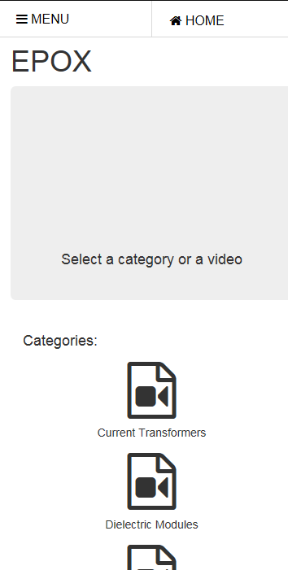
Bootstrap makes I-Tube look different on mobile by putting everything into a single row
All div.sml_video are nested inside div. col-sm-3.

All div.playlist are nested inside col-sm-2.

A div with a class that is col-sm-2 or col-sm-3 is a class for bootstrap. Bootstrap organizes pages into 12 columns. Col-sm-2 means when the screen is small (750px) or larger, any div with this class will take up 2 of the 12 columns. Col-sm-3 will take up 3 columns. Any columns must be in a div.row. Since 3*4 is 12, col-sm-3 will be 4 to a row, while col-sm-2 will be 6 to a row.

